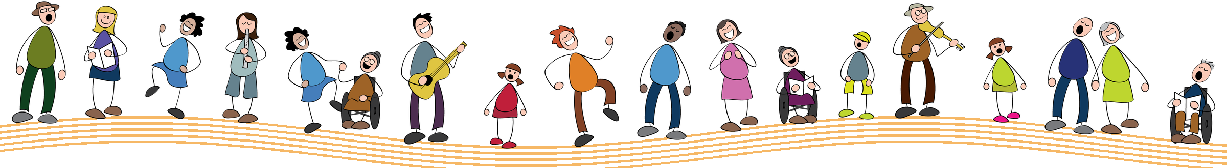
   | Making a difference in someone’s life through song ♫  Join us for the 20th edition  on Saturday, February 6, 2027  www.journeejoie.org
  Making a difference in someone’s life through song ♫
  Join us for the 20th edition
  on Saturday, February 6, 2027
  www.journeejoie.org
  Making a difference in someone’s life through song ♫
  Join us for the 20th edition
  on Saturday, February 6, 2027
  www.journeejoie.org
  Making a difference in someone’s life through song ♫
  Join us for the 20th edition
  on Saturday, February 6, 2027
  www.journeejoie.org
  Making a difference in someone’s life through song ♫
  Join us for the 20th edition
  on Saturday, February 6, 2027
  www.journeejoie.org
  Making a difference in someone’s life through song ♫
  Join us for the 20th edition
  on Saturday, February 6, 2027
  www.journeejoie.org
  Making a difference in someone’s life through song ♫
  Join us for the 20th edition
  on Saturday, February 6, 2027
  www.journeejoie.org
  Making a difference in someone’s life through song ♫
  Join us for the 20th edition
  on Saturday, February 6, 2027
  www.journeejoie.org
  Making a difference in someone’s life through song ♫
  Join us for the 20th edition
  on Saturday, February 6, 2027
  www.journeejoie.org
  Making a difference in someone’s life through song ♫
  Join us for the 20th edition
  on Saturday, February 6, 2027
  www.journeejoie.org

