  “Joy shared is joy doubled!”  Thank you!  Project website:  www.journeejoie.org |   Today,  Sol-La-S’Day | “Joy shared is joy doubled!”  Thank you!  Project website:  www.journeejoie.org |   Today,  Sol-La-S’Day
“Joy shared is joy doubled!”  Thank you!  Project website:  www.journeejoie.org |   Today,  Sol-La-S’Day | “Joy shared is joy doubled!”  Thank you!  Project website:  www.journeejoie.org |   Today,  Sol-La-S’Day
“Joy shared is joy doubled!”  Thank you!  Project website:  www.journeejoie.org |   Today,  Sol-La-S’Day | “Joy shared is joy doubled!”  Thank you!  Project website:  www.journeejoie.org |   Today,  Sol-La-S’Day
“Joy shared is joy doubled!”  Thank you!  Project website:  www.journeejoie.org |   Today,  Sol-La-S’Day | “Joy shared is joy doubled!”  Thank you!  Project website:  www.journeejoie.org | 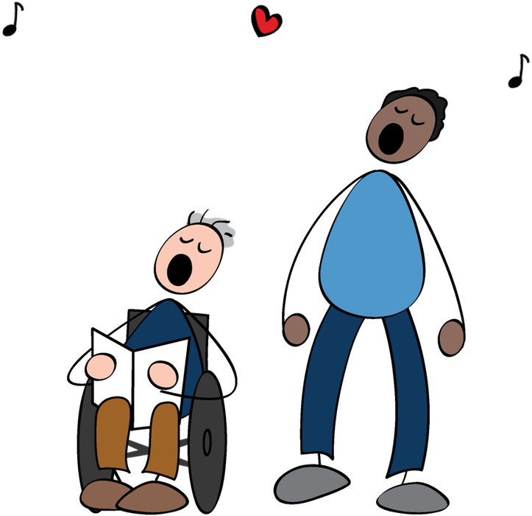  Today,  Sol-La-S’Day
“Joy shared is joy doubled!”  Thank you!  Project website:  www.journeejoie.org | 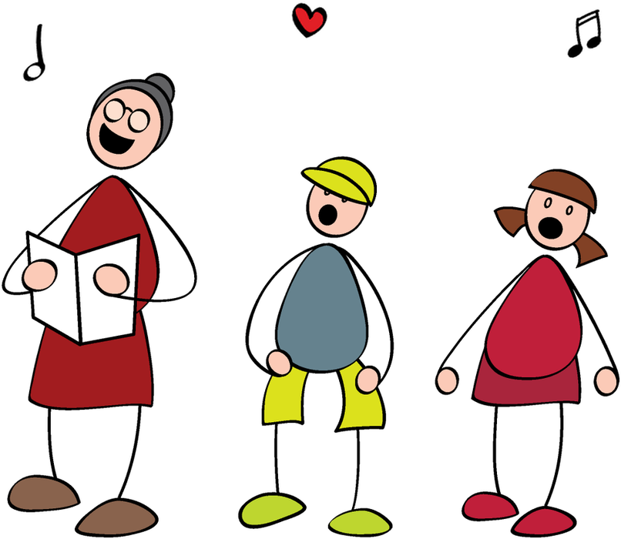  Today,  Sol-La-S’Day | “Joy shared is joy doubled!”  Thank you!  Project website:  www.journeejoie.org |   Today,  Sol-La-S’Day

