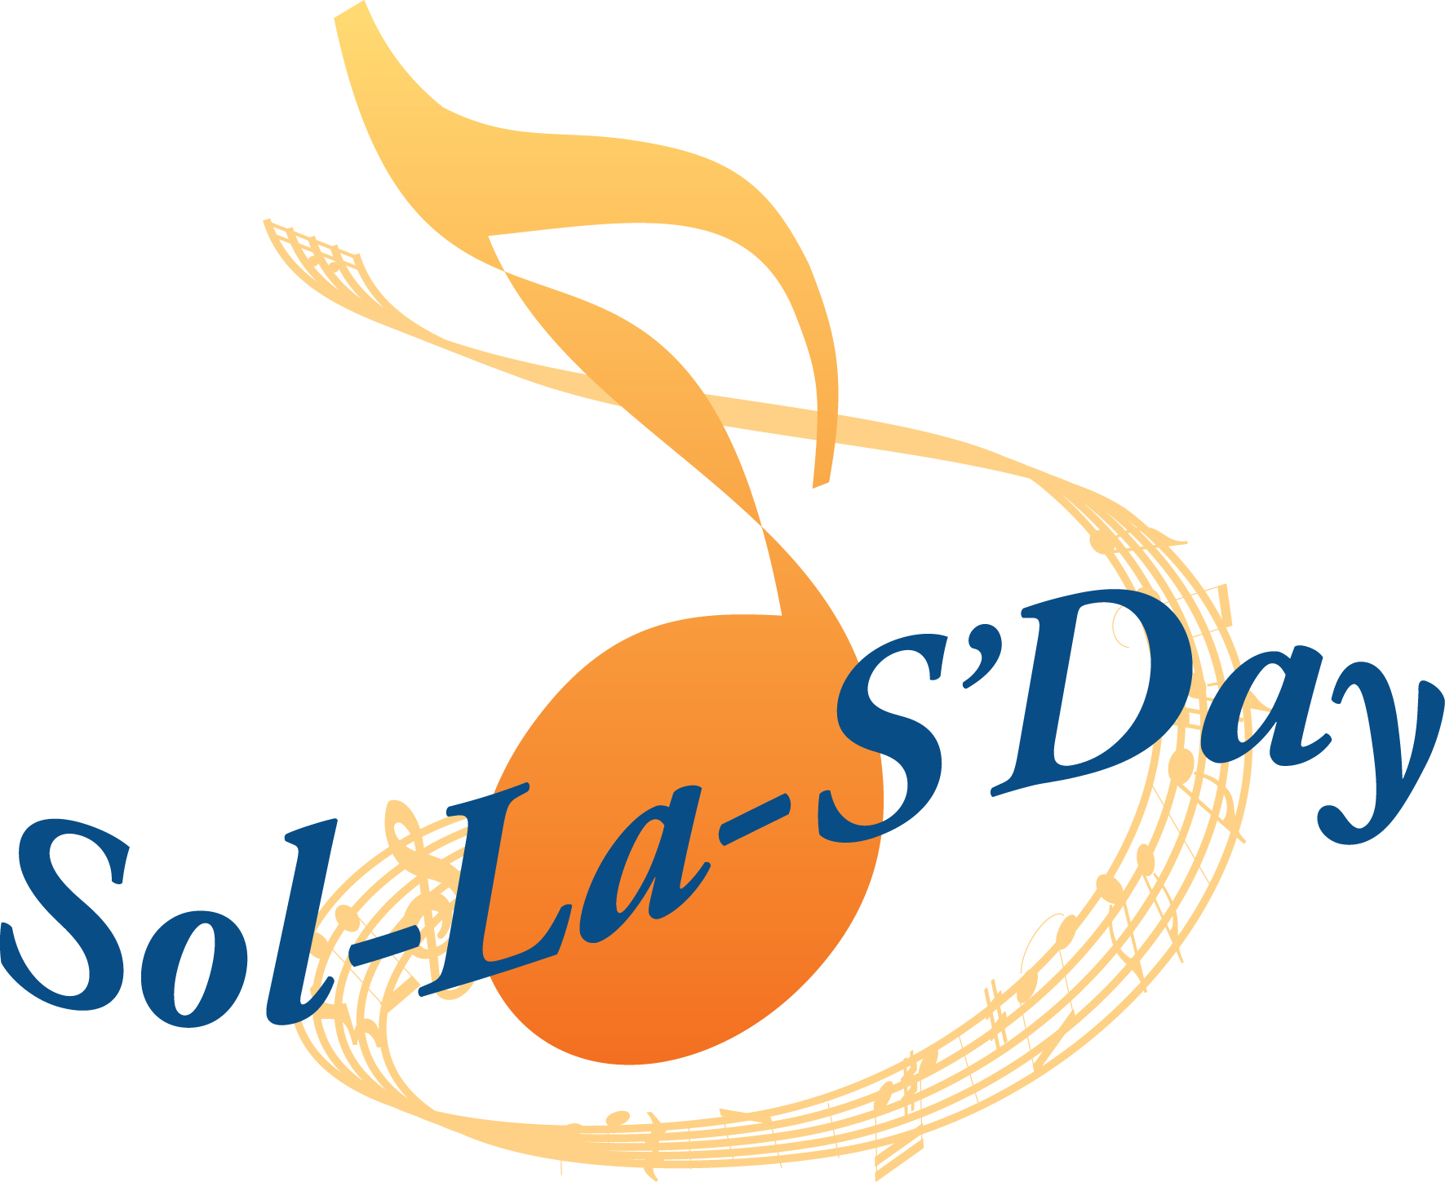
Saturday
February 6
2021

Welcome to our SING-ALONG!

When: ________
Where: ________

GOOD MEMORIES & GOOD MUSIC!!

SOL-LA-S’DAY’s 17th edition is taking place across the province, throughout Canada and around the world. COME AND JOIN US!

