
PRESS RELEASE

January 10th, 2019

FOR immEdiate ReLEASE

''Sol-La-S’day'' is a great initiative and an opportunity to share joy through singing! The 15th edition of this annual event will be held on Saturday, February 2nd, 2019; it aims at bringing together good-hearted people who are willing to make a difference, a positive impact in the life of others who may feel lonely, neglected or miserable.

Participation is very easy and offers a rewarding opportunity to share into a very enriching experience; you don’t have to be accomplished singer or musician and no practice is necessary. Although a minimal organization and preparation are involved, spontaneity is important: reaching for the lonely and timid, sharing a seat and a songbook, trading smiles and hugs: magic will take place!

This 4 easy-steps approach will facilitate your preparation:

- Bring together a small group of 5 to 10 people, family members, friends, work colleagues.
- Determine a host-place (seniors’ residence, hospital, …) and contact the person in charge of social activities or manager to confirm your availability
- Put together a songbook with the help available on our web site: lyrics for more than 150 French language songs and 100 English language songs are listed
- Register using our web-friendly online registration. Registration is free, but required.

This project originated in Québec in 2005. Since its inception, more than 7500 “sol-la-singers” have brightened the day of more than 34,000 people through these impromptu sing-alongs. From year to year, the event blossomed, both nationally and internationally, to include other Canadian provinces and other countries such as Italy, France, Belgium, Costa-Rica, Martinique, Guadeloupe and Senegal.

On “Sol-La-S’day”, all participants and groups participating in the event generate a tsunami of love and joy through their songs and music. Please, be part of this wave! To register your group or learn more about this event, feel free to visit our web site at www.journeejoie.org or to contact me personally by email.

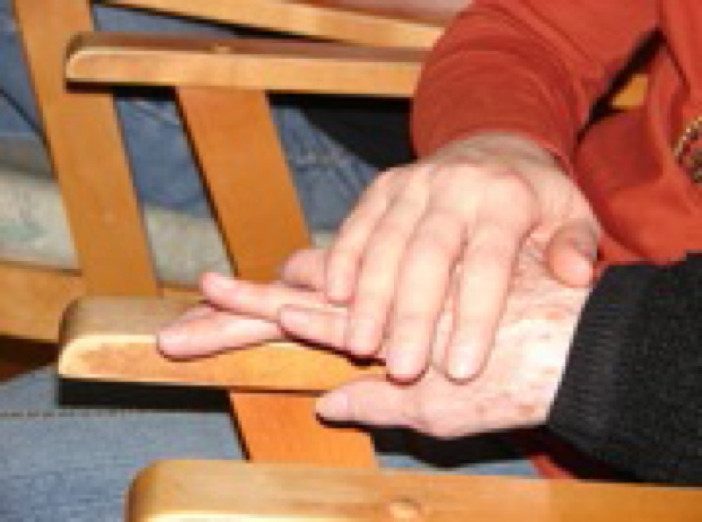
Thank you!

-30-

Information :
Julie Lecours, Project manager
solasiday@gmail.com | 514-999-1000

